St. Mary’s Faith Formation
2022-2023 Handbook

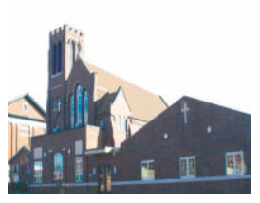

St. Mary’s Catholic Church
512 W. Thomas Avenue
Shenandoah, IA 51601
712-246-1718 – office
Website: www.stmarysiowa.org
Facebook: St. Mary’s Catholic Church-Shenandoah, Iowa

Jesus said, “Let the little children come to me, and do not hinder them, for the kingdom of Heaven belongs to such as these.”
Matthew 19:14
CLASS TIMES Pre-K through 6th Grade
Pre-K through 6th grade will meet in the Religious Education Classrooms from
9:00 AM to 10:15 AM every Sunday prior to 10:30 AM Mass; 7th and 8th Grade will also meet from 9:00 AM to 10:15 AM every Sunday, however they will meet in the Youth Ministry classroom in the church basement.
YOUTH MINISTRY SESSION TIMES 9th Grade through 12th Grade
Youth Ministry Sessions will be determined at a student/parent meeting; time TBD.
Please refer to the yearly calendar for any special dates, times and special events.
Times may vary through the year. Parents will be notified of any changes in a note sent home with their child. We will make every effort to notify you of any changes. Refer to our Facebook page at St. Mary’s Catholic Church-Shenandoah, Iowa of any changes.

RECONCILIATION AND FIRST HOLY COMMUNION
Requirements to receive Sacraments include 2nd grade or above, must meet attendance requirements including; lessons and Sacrament preparation retreats. These retreats are mandatory. If your child is of age and prepared to receive these Sacraments, please contact Kim Leininger, DRE at 712-215-1505 or email kimleininger515@gmail.com
CONFIRMATION
Students 10th grade and above that meet requirements are eligible to receive this Sacrament. This Sacrament is offered every 2 years. Meeting times will vary based on liturgical calendar. For information in regards to this Sacrament, contact Gigi DeSa, Youth Ministry Leader at 712-313-1181 or email button61@icloud.com

BEHAVIOR
- Kids will be kids; however, children are expected to be on their best behavior at all times.
- All Children and youth are expected to behave in a proper manner. Respect and full cooperation are expected.
- Children and youth are to actively participate in all classroom activities.
- Though not anticipated, parents will be contacted in case of behavioral issues.

FOR YOUR CHILD’S SAFETY
- Pre-K through 6th grade must be picked up by a parent or older sibling. If your child is being picked up by someone other than a parent or older sibling, a note must be provided to the teacher prior to class.

St. Mary’s Parish Community reminds you:
- “The Eucharist is our source of the Catholic life.” Attendance at Mass should be a priority for you and your child. This will help your child to gain full knowledge and respect for this Sacrament. The Eucharist is our privilege and must be taken seriously.
  - Religious Faith Formation is a life-long process for everyone. Attendance at faith formation classes should be a priority for you and your child.
  - Practice prayer regularly with your family.
- Participation in the life of our parish community is important. As parents, you are the primary catechists and examples for your child. Your participation in the life of our church and community is essential for your own faith formation as well as your child’s.
- Talk with your child about what they are doing in their classes.
- We encourage parents and grandparents to join in the classroom at anytime.

As catechists we promise to:
- Provide support and encouragement to parents and families.
- Provide a safe and learning environment where the message of Jesus Christ and the truths and traditions of our Catholic faith can be explored openly.
- Provide a caring and nurturing environment for our parish community.
- Provide opportunities for participation in Liturgy, Sacraments, and Prayer.
- Provide opportunities to reach out to members of our parish family, and opportunities for service to the larger community.

PROCEDURES FOR CANCELLATIONS
For cancellations due to inclement weather or other unforeseen circumstances, announcements will be posted on our Facebook page at St. Mary’s Catholic Church-Shenandoah, Iowa. Additionally, every attempt will be made to contact you by phone, text, or email as noted on your registration form.

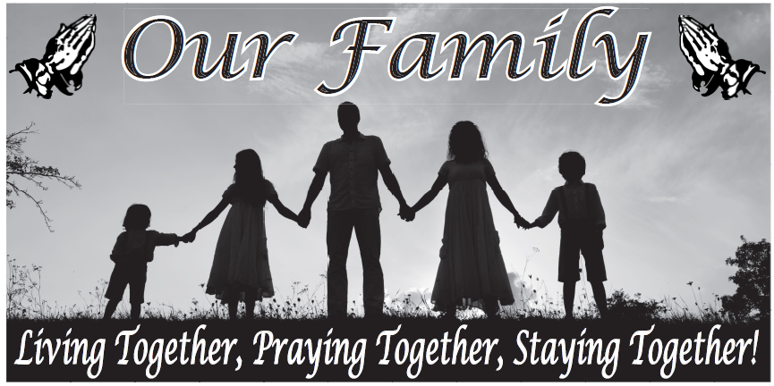

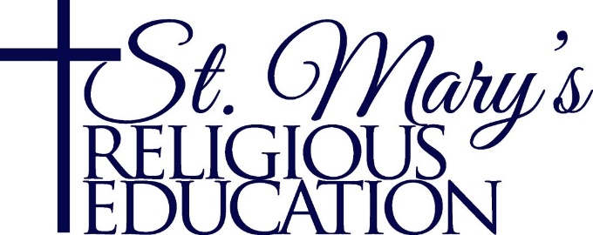
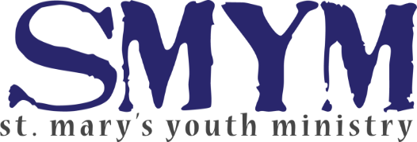

Parental Acknowledgement

Thank you for choosing to enroll your child(ren) in St. Mary’s Catholic Religious Education classes.
By signing below:
“We commit our family to be active participants in the life of our parish and attend Mass regularly. We recognize that only with our support can Religious Education continue to flourish. I will educate my child, along with the help of St. Mary’s catechetical leaders, in our Catholic Faith. My child(ren) will attend Mass and Religious Education classes regularly.
Signature of Parent or Legal Guardian
__________________________ Date ________________________
Signature of Director of Religious Education
__________________________ Date ________________________
Signature of Youth Ministry Leader
__________________________ Date ________________________

I would like my child to participate in the Mass Duties

- Mass is a liturgical celebration of words and actions that symbolize and represent meanings within the Catholic teachings and tradition.
- The involvement of parents, teachers, friends, and community members in the liturgy provide a deeper sense of belonging, identity and perhaps security for your child.
- The stimulation of the senses of hearing, seeing, smelling, touching and tasting in the public celebration of the liturgy shows the versatility of the activities.
- Children’s sense of occasion and awareness of growth or cycle in the seasons are deepened. Christmas, Lent, Palm Sunday, Easter, and other significant events in the church calendar do help kids understand elements of permanence, change, consistency and dynamism. Changes in season reflect the different times, mood, prayer and events in life. Narratives associated in those seasons add meaning into those realities.

Altar Serving: In order to become an alter server, one must have completed the Sacraments of Reconciliation and 1st Holy Communion. By becoming an Altar Server, my child agrees that this is a commitment to serve on the altar when scheduled or to find a substitute if my child is unable to serve when scheduled. My child will also attend trainings.

_____ Altar Serving (3rd – 12th grade) _____ Cantoring (7th – 12th grade) _____ Ushering (7th – 12th grade) _____ Lecturing (7th – 12th grade)

Mass Times that your child can serve: 4:30PM __ 6:30AM __ 10:30AM__

Child’s Name(s): ____________________________________________
____________________________________________
____________________________________________
____________________________________________
Parent Name: _________________ Signature: ___________________
For further information, please contact: Kim Leininger, DRE Phone: 712-215-1505 kimleininger515@gmail.com or Gigi DeSa Youth Ministry Leader 712-313-1181 or email button61@icloud.com

